**SOHAM TIWARI**

**OS LAB 2 CSE C 43 07/12/20 180905360**

**1. GREP**

#include<unistd.h>

#include<sys/stat.h>

#include<fcntl.h>

#include<stdlib.h>

#include <string.h>

#include<stdio.h>

int main(int argc, char const *argv[])

{

if(argc!=3)

{

write(2, "There should be 3 arguments specified\n", 38);

exit(1);

}

int sfd = open(argv[2], O_RDONLY); //source file descriptor

printf("%s\n", argv[1] );

if(sfd==-1)

{

write(2, "Source file does not exist\n", 27);

exit(1);

}

char line[100]="";

char c;

int no_of_lines = 0;

// argv[0] - binary filename currently being executed

// argv[1] - additional argument 1

// argv[2] - additional argument 2

while(read(sfd, &c, sizeof(char))>0)

// while(read(sfd, &c, sizeof(char))!=0)

{

if(c!='\n')

{

strncat(line, &c, 1);

}

else

{

no_of_lines++;

if(strstr(line, argv[1])!=NULL)

{

printf("Line %d: %s\n",no_of_lines, line );

}

line[0] = '\0';

}

}

close(sfd);

return 0;

}

Output:

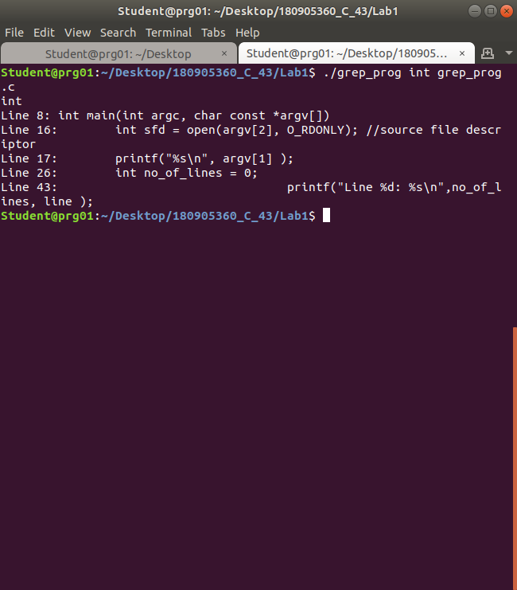

**2. MORE**

#include<unistd.h>

#include<sys/stat.h>

#include<fcntl.h>

#include<stdlib.h>

#include <string.h>

#include<stdio.h>

int main(int argc, char const *argv[])

{

if(argc<2)

{

write(2, "There should be 2 arguments specified\n", 38);

exit(1);

}

for(int i = 1; i<argc; i++)

{

int sfd = open(argv[i], O_RDONLY); //source file descriptor

printf("\nReading file %s ...\n", argv[i] );

if(sfd==-1)

{

write(2, "Source file does not exist\n", 27);

// exit(1);

continue;

}

char line[100]="";

char c, waste;

int no_of_lines = 0;

int ctr = 0;

while(read(sfd, &c, sizeof(char))>0)

{

if(c!='\n' && c!='\0')

{

strncat(line, &c, 1);

}

else

{

no_of_lines++;

ctr++;

printf("%d: %s\n",no_of_lines, line );

line[0] = '\0';

if(ctr==20)

{

ctr=0;

printf("Enter q(quit) or any other key to continue\n");

fflush(stdin);

// while(read(0, &c, 1)==0);

// c = getchar();

scanf("%c", &c);

if(c!='\n')

scanf("%c", &waste);

fflush(stdin);

if(c=='q')

{

printf("Exiting...\n");

fflush(stdin);

// exit(0);

// continue;

break;

}

}

}

}

// printf("Closing file %s\n\n", argv[i] );

// fflush(0);

close(sfd);

}

// return 0;

exit(0);

}

OUTPUT:

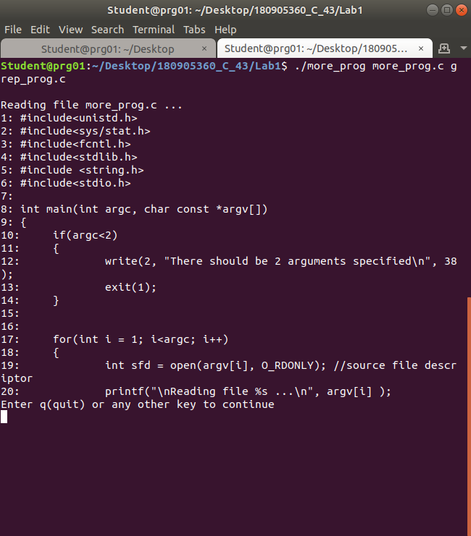

**3. CONVERSION SPECIFIERS**

#include<stdio.h>

#include<errno.h>

int main(int argc, char const *argv[])

{

int x = -23;

unsigned int y = 25;

float z = 3.14;

double d = 424242.171717;

char c = 'h';

char str[]="Hello world!";

errno = EPERM;

printf("Integer: %d\n", x);

printf("unsigned Integer %u\n", y);

printf("Hexadecimal versionsof both: %#x %#x\n",x, y);

printf("float: %f\n", z);

printf("double %3.3lf\n", d);

printf("STRING %s\n", str);

printf("CHAR %c\n", c);

printf("ERR %m\n" );

return 0;

}

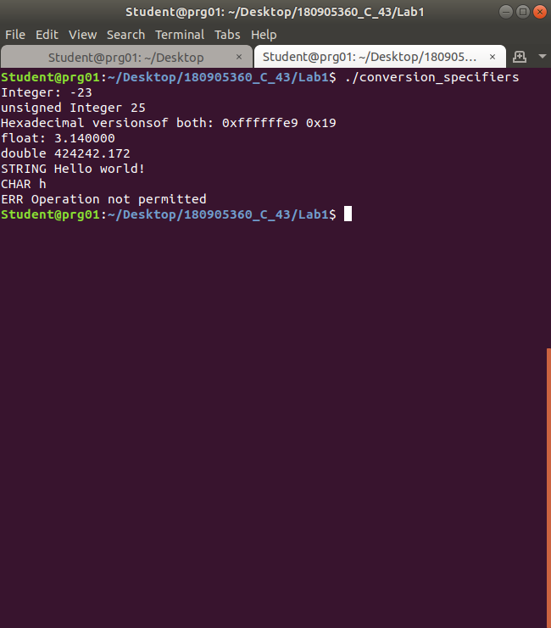OUTPUT:

**4. COPY**

#include<unistd.h>

#include<sys/stat.h>

#include<fcntl.h>

#include<stdlib.h>

#include<stdio.h>

int main(int argc, char const *argv[])

{

// char c;

if(argc!=3)

{

printf("You need to provide 2 files names as input args\n");

exit(1);

}

FILE *in, *out;// file descriptors

in = (FILE*)fopen(argv[1], "r");

out = (FILE*)fopen(argv[2], "w+");

// while(fgetc == 1)

// write(out, &c, 1);

while(1)

{

if(feof(in))

break;

fputc(fgetc(in), out);

}

fclose(in);

fclose(out);

return 0;

}

OUTPUT:

